**Powershell notes**

Out-file (saves as a file)

Out-gridview (opens up in a window)

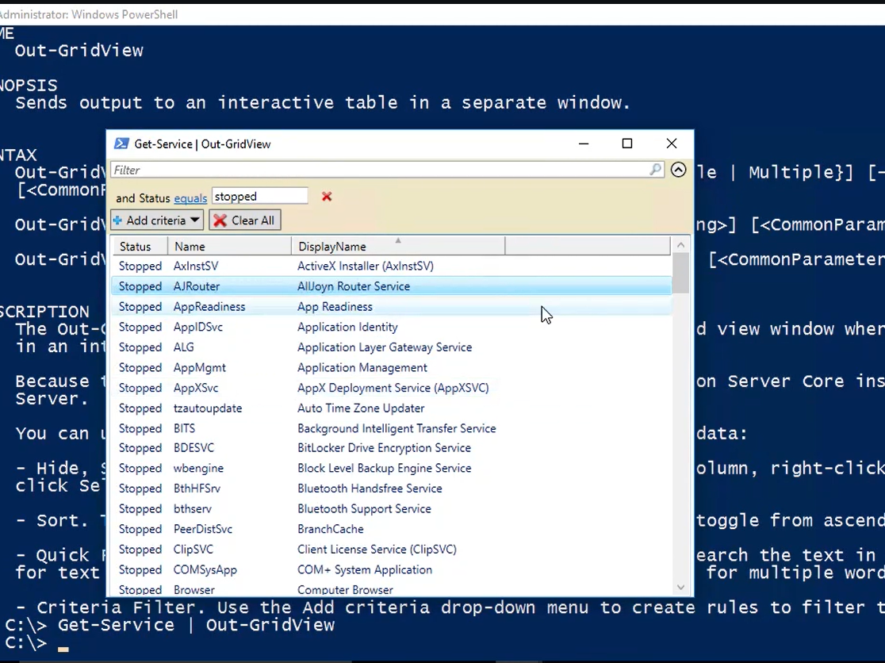

Out-printer (sends to the printer)

Eg. Get-service | sort status,name | outfile C:\users\jessw\desktop\test.txt

To open the file: notepad C:\users\jessw\desktop\test.txt

